# **CHAPTER FOUR**

# **RESULTS AND DISCUSSION**

## 4.0 INTRODUCTION

Software documentation is a written text that accompanies computer software. It explains how the software operates and how to use the system. Types of documentation include:

**User** documentation, it is intended to help the users of the system, it explains how to start / stop the system, how to use the features of the system. The users are usually **non-technical** people such as students and supervisors, who don't need to know how the system works. They just need to know **how to use it**.

The technical documentation is intended to help the **maintainers** of the system (the people who need to keep the system running smoothly, fix problems, etc.). The maintainers are usually **technical** people, who need to know exactly **how the system works**. In this system, they are the project coordinators.

**4.1 Featutres of the system**

**4.1.1 Home Page**

This page is the first page of the system consisting of the title of the software. The specific aims of the page are to:

1. Introduce user to the software.
2. To signify the start of the system.

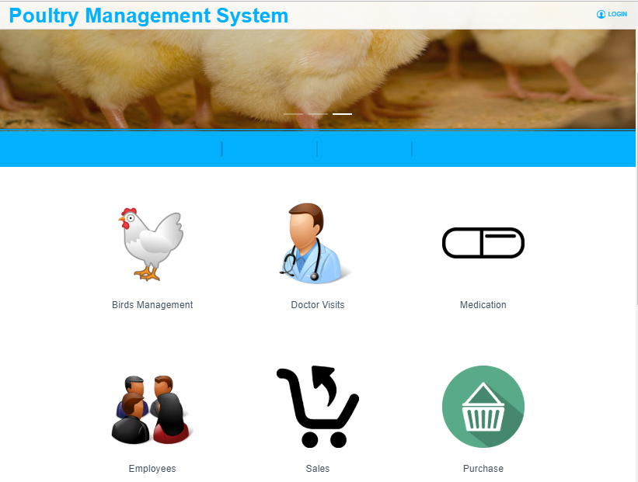

Figure 4.1: Home page

**4.1.2 Login page**

The login provides a mechanism for authenticating the user inot the system, user has to login with his username and password before gaining access to the system

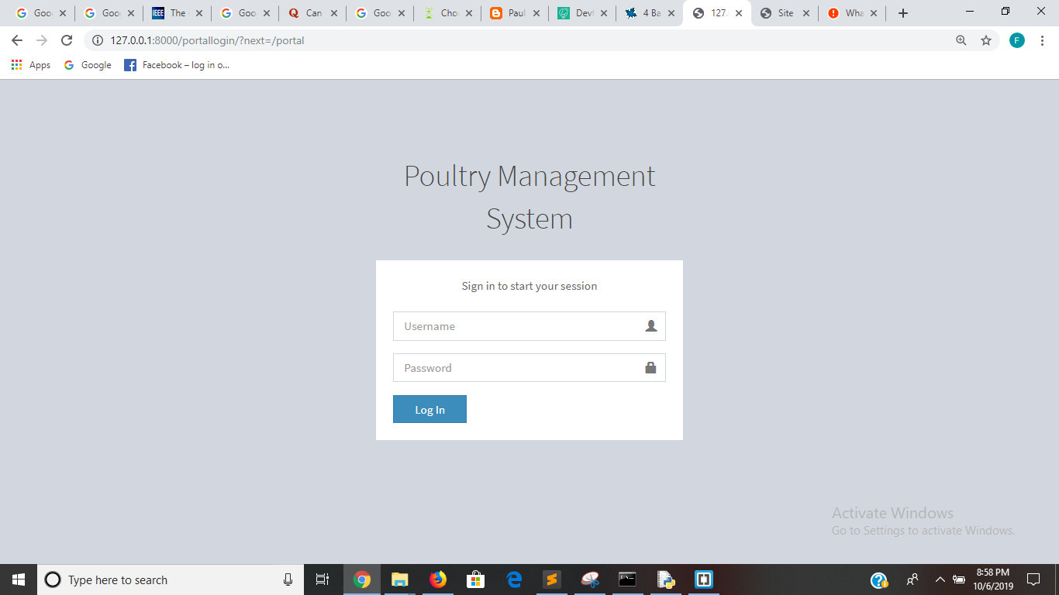

Figure 4.2: Login page

**4.1.3 Users**

The system has an administrator that has the all the controls of the system. The administor can add other users and set their roles and permissions for read and write the system.

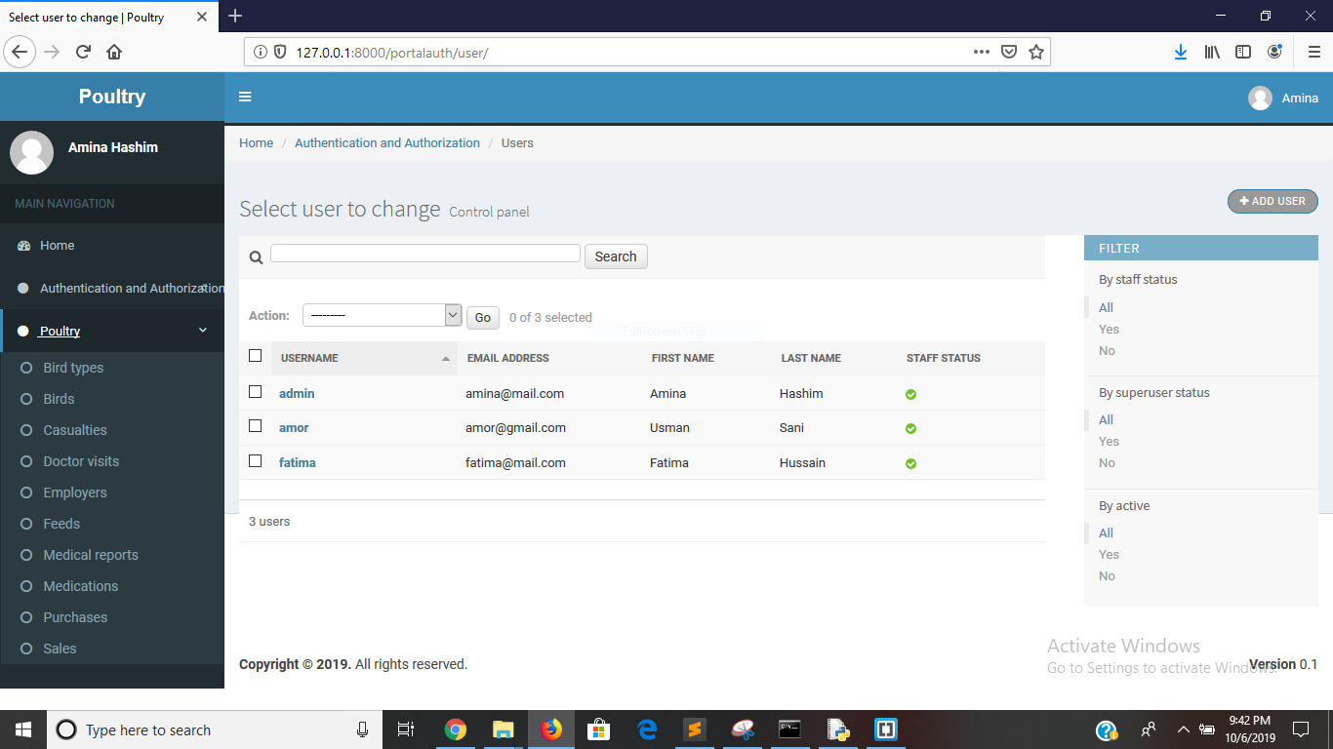

Figure 4.3: users of the system

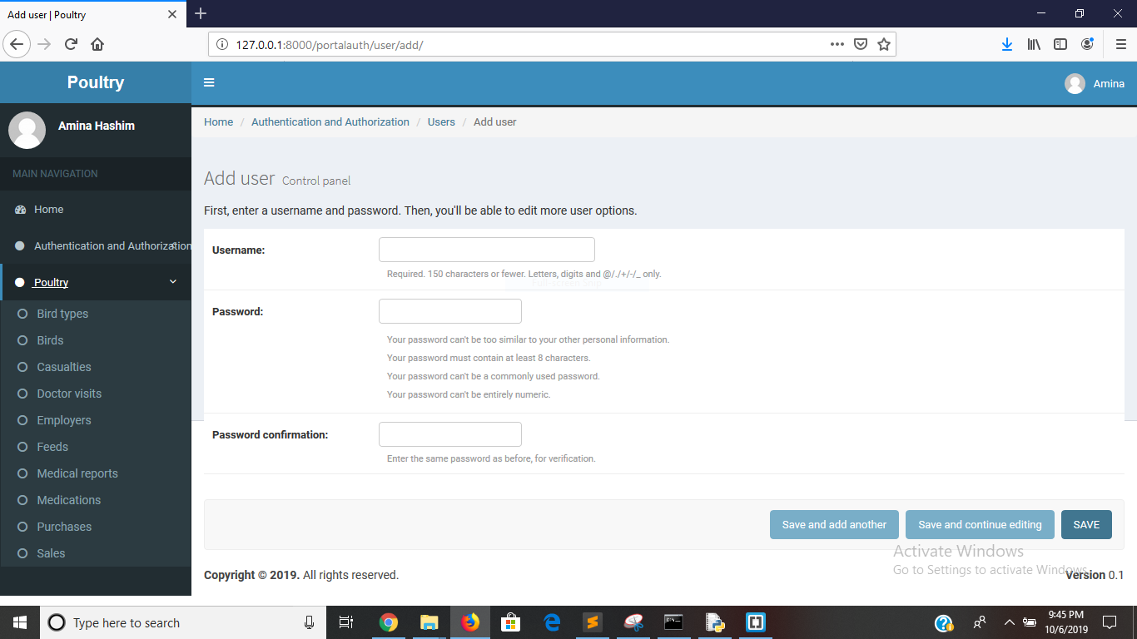

Figure 4.4: user add form

**4.1.4: Birds Types**

This module enables the management of the different categories of the birds in the system.

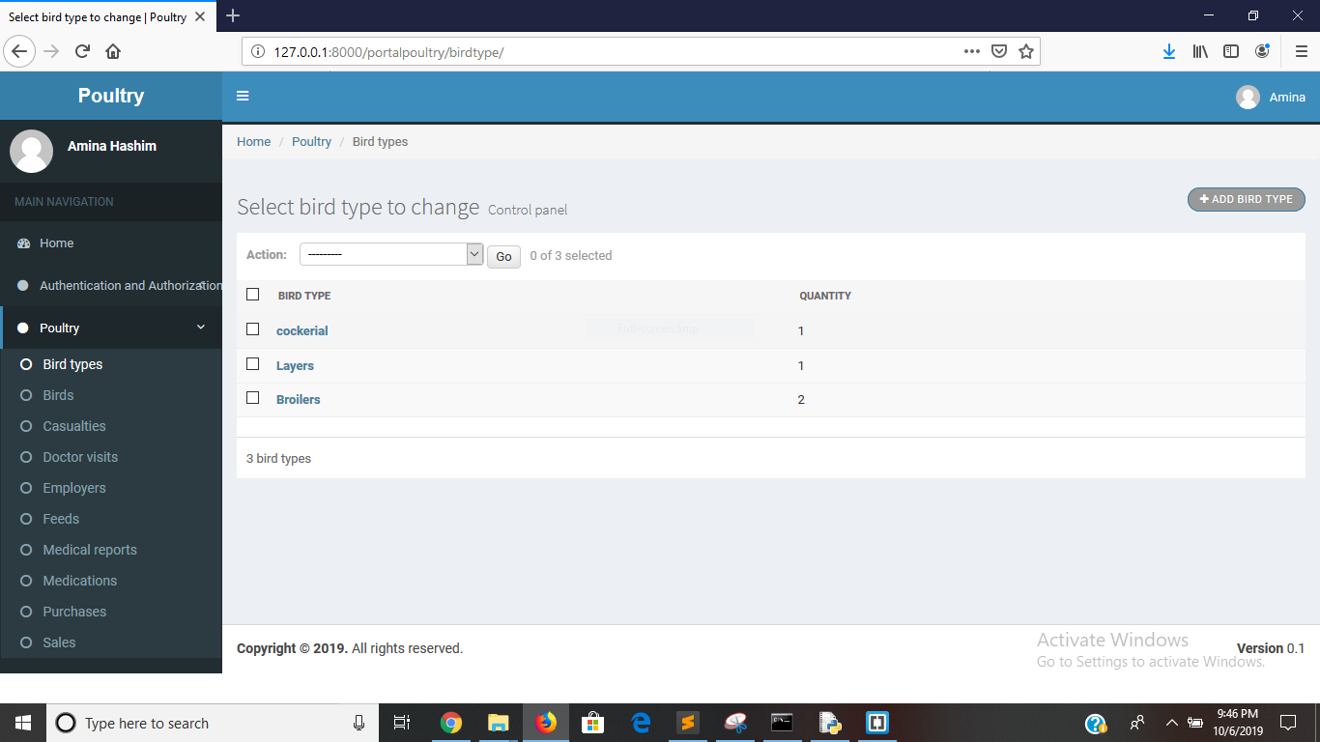

Figure 4.5: Bird Types

**4.1.5 Birds**

This module enables the management of the different birds in the system.

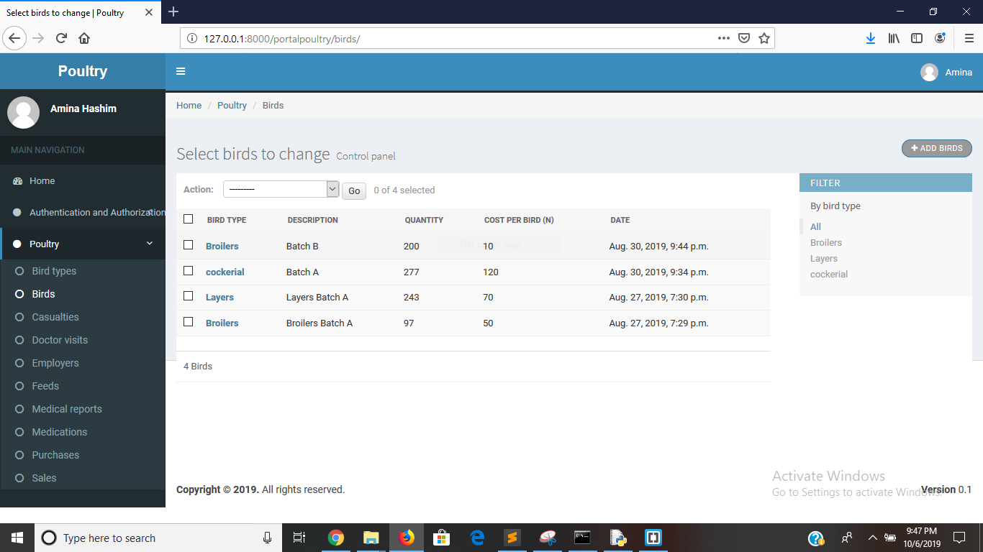

Figure 4.6: Birds in the system

**4.1.6 Casualties**

This module enables the management of the casualties that affects the birds, which may be death or damage

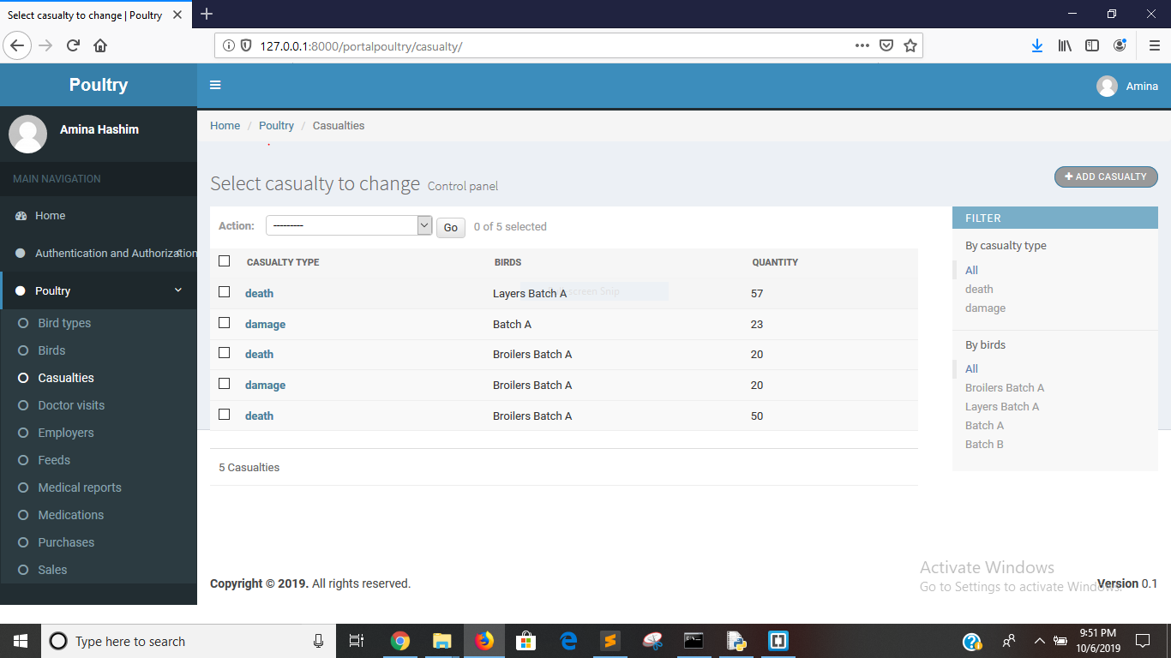

Figure 4.7: casualties

**4..1.7 Doctor Visists**

This module enables the management of the doctor visist to the poultry

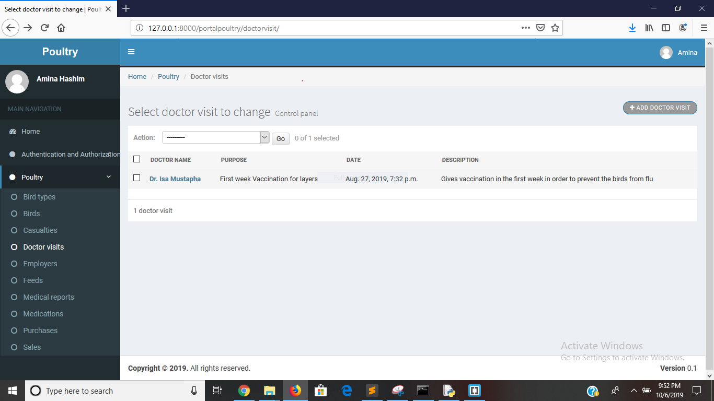

Figure 4.8: doctor visist

**4.1.8: Employees**

This module enables the management of the employees of the poultry

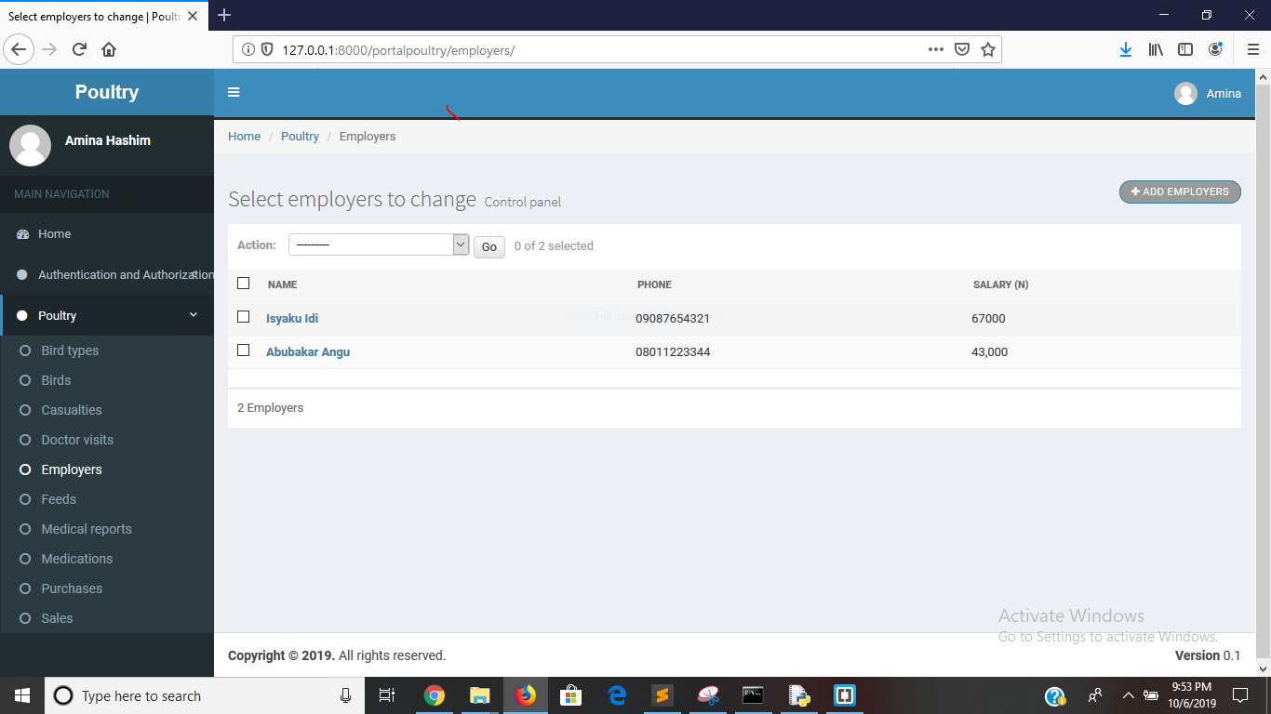

Figure 4.9: employees

**4.1.9: Feed**

This module enables the management of the employees

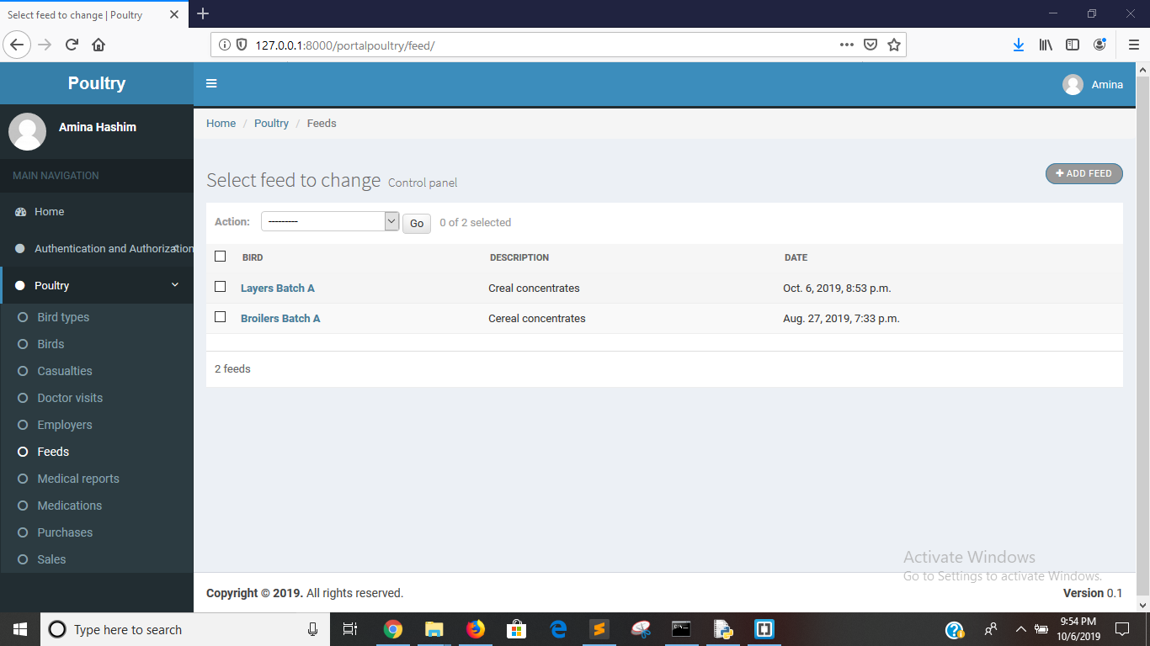

Figure 4.9: Feeds

**4.1.9: Medical Report**

This module enables the management of the medical reports of the birds

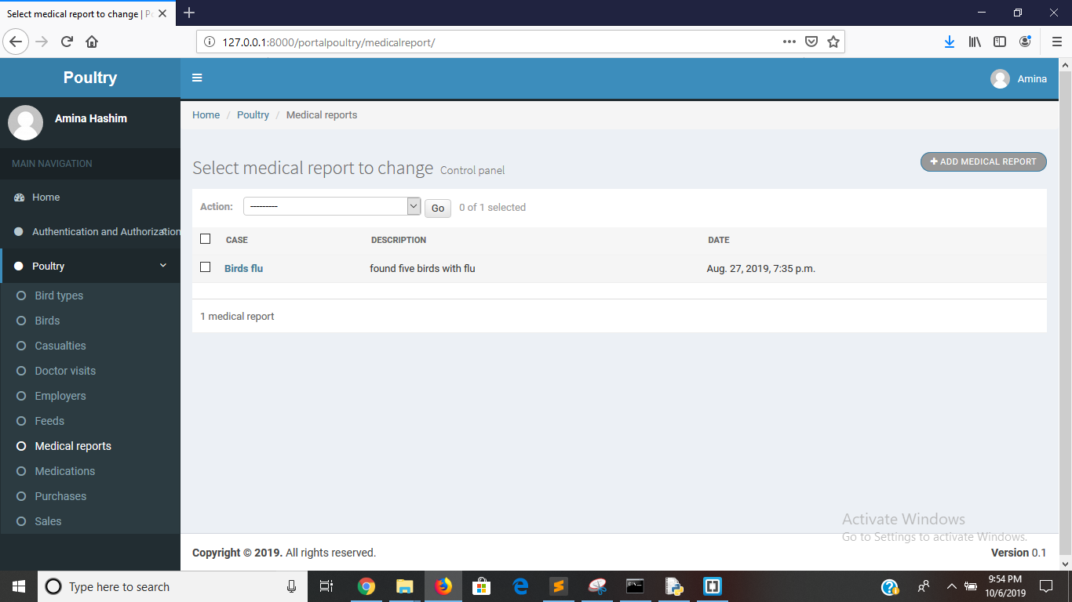

Figure 4.9: medical report

**4.1.10: Purchase**

This module enables the management of the purchases made in the poultry

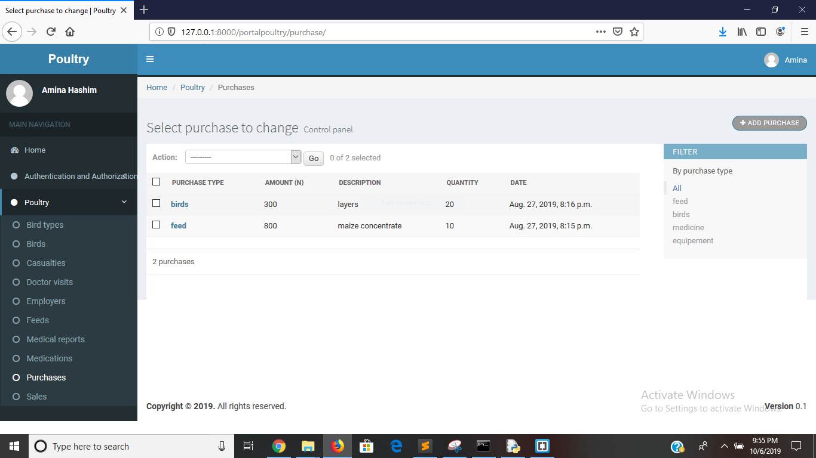

Figure 4.10: purchase

4.1.11: Sales

This module enables the management of the sales made in the poultry

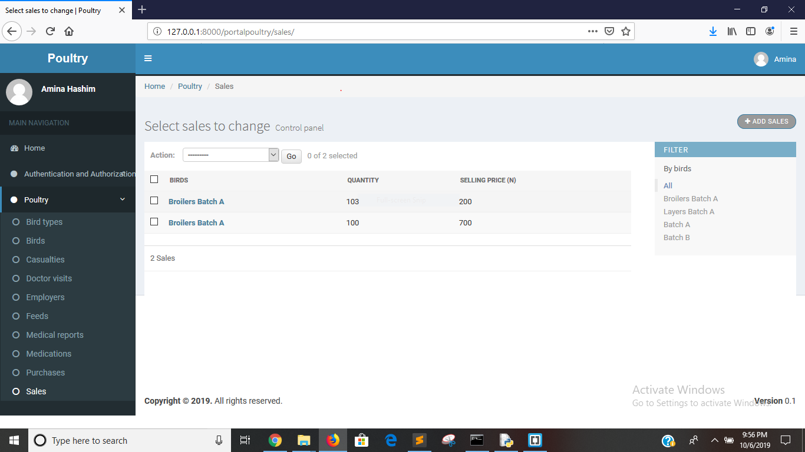

Figure 4.11: sales

**4.2 Limitations of the system**

1. Doesn’t support pictures of the birds
2. Limited to only birds that are uploaded in the system
3. Limited to only birds